**PROJECT TITLE** : **Application of Machine Learning Techniques for Tongue Diagnosis in Ayurveda**

**Abstract:**

The analysis of tongue image is a very crucial approach in order to evaluate human health in Ayurveda medication. As a result of the modification in tongue colour might counsel physical or mental disorders. Diagnostic technique informs the practitioner related to the human organs and the body system. Many tongue colour quantification strategies for tongue diagnosis are published by many researchers in Chinese medication. However, reliable tongue color analysis algorithms are limited for ayurveda medicine.

The main objective of this paper is to apply advanced techniques and algorithms of digital image processing and Machine learning to quantify and verify clinical knowledge of tongue colour identification by characterizing variations in tongue features. Tongue images are captured from good quality camera with sufficient lighting conditions, and collected about 260 tongue images. Based on the variations of the color and texture on different portion of the tongue such as top, middle and bottom corresponding to vata, pitta, and kapha respectively. There are 7 types of constitution based on vata,pitta,kapha. Each of these portions are classified under RGB color model and there are many color spaces defined for different purposes. We designed a set of 25 features that span the entire color space model. We use segmentation method to extract the tongue part of the image and then we apply Clustering Algorithm to separate tongue body and coating area. The result of segmenting tongue body and coating is very good in CIELAB color space.

The tongue of a healthy person is pinkish in color, moves freely and is gently moist with a light coating. If a tongue changes color or texture, tongue diagnosis may be used to detect vitamin deficiencies, poor circulation, high cholesterol, allergies or digestive problems. Tongue color can range from pale pink to red or even have a bluish tinge. The tongue color reflects the distribution of body fluids throughout the body.

**HISTORY**

**Ayurveda** is a system of medicine with historical roots in the [Indian subcontinent](https://en.wikipedia.org/wiki/Indian_subcontinent). Globalized and modernized practices derived from Ayurveda traditions are a type of [alternative medicine](https://en.wikipedia.org/wiki/Alternative_medicine).In countries beyond India, Ayurvedic therapies and practices have been integrated in general [wellness](https://en.wikipedia.org/wiki/Wellness_(alternative_medicine)) applications and in some cases in medical use.

Ancientayurveda deals with the analysis of a human being purely based on the physical appearance of few characteristics namely the tongue, pulse, eyes etc. The analysis was to be done by an individual and would be diagnosed and treated for the same accordingly. With the advancement of science and technology there is a diminishing usage of ayurvedic principles and it’s usage for treating ailment. This has led to a abundance of gap between the technology and tools of the modern day and the principles and techniques used in the earlier days. A semi-supervised model which could help the medical professionals in the betterment of treating the ailment, would improve the accuracy as there is less of human intervention.

Tongue Diagnosis is a vital instrument used in Ayurvedic medicine both for assessing a person’s current state of health and providing a basis for prognosis. Ayurveda, an oldest Known healing modality in the world, describes tongue diagnosis as a technique to determine a person’s state of physical, mental and emotional health. This diagnostic technique informs the practitioner of underlying challenges and strengths in organs and body systems.

The ancient art of Tongue Diagnosis may be defined as the science of the shape, shadings and markings of the tongue to describe the current state of an individual’s health as well as their inherited constitution. It also reveals energetic and physical imbalances.

In Ayurveda we view a person as a unique individual made up of a five primary elements: Air, Fire, Water, Earth and Ether. These elements have an ability to combine to create various physiological functions. Ether and Air combine to form what is known in Ayurveda as the Vata Dosha. Vata governs the principle of movement and therefore can be seen as the force that directs nerve impulses, circulation, respiration and elimination. Fire and Water are the elements that combine to form Pitta Dosha. The Pitta Dosha is the process of transformation or metabolism. Finally, it is predominantly the Water and Earth elements that combine to form the Kapha Dosha. Kapha is hat responsible for growth and adding structure unit by unit and also protection.

Vata, pitta and kapha each have their own attributes, and substances having similar attributes will tend to aggravate the related bodily humor by the law of like-increases-like. For instance, the summer season has attributes similar to those of pitta — hot, dry, light, motile and penetrating. Naturally, in the summer, pitta in the body will be aggravated. Vata is light, subtle, dry, mobile, rough and cold. So, in the fall season, which also exhibits these attributes, vata will tend to be aggravated in the human constitution. Lastly, kapha is liquid, heavy, cold, sticky and cloudy; so in winter when these characteristics predominate in the external environment. Through understanding of these attributes, balance of the tridosha may be maintained. Three elements vata - pitta - kapha govern all the biological, psychological and physiopathological functions of the body, mind and consciousness. There are seven types of constitutions: (1) vata, (2) pitta, (3) kapha, (4) vata-pitta, (5) pitta-kapha, (6) vata-kapha and (7) vata-pitta-kapha.

The below diagram shows how tongue can be classified based on the tri-Dosha.

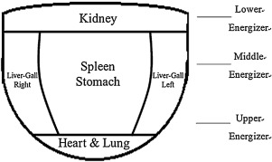

**LITERATURE**

We have studied and analyzed the tongue shape to establish a kind of tongue diagnosis method based on tongue images. Traditional Chinese Medicine (TCM) has a long history and has been recognized as a popular alternative medicine in western countries. An author proposed a fully automatic tongue detection and tongue segmentation framework, which is an essential step in computer-aided tongue image analysis. Comparing with other existing methods, this method is fully automatic without any need of adjusting parameters for different images and do not need any initialization.

A tongue is an organ that reflects physiological and clinic pathological condition of one’s body. Each part of the tongue is related to corresponding internal organs. Especially, the visual information is used in tongue diagnosis. The color, the form, and the motion of a tongue, tongue substance, and tongue coating are main factors for the diagnosis. The geometrical shape also helps to diagnose one’s health, whose method diagnoses the illness by observing the change of the tongue body such as thickness, size, cracks, and teeth-marks. The tongue coating, covered on a tongue like moss is the most important factor, depending on colour, degree of wetness, thickness, form, and distributed range to determine a patient’s disease and body condition. It is classified by its color – white, yellow, grayish, black, mixed colour, and so on. Even if a tongue diagnosis is convenient and non-invasive, it has the problem of objectification and standardization. The change of the inspection circumstance like a light source affects the result a lot. Moreover, since the diagnosis relies on doctor’s experience and knowledge, it is hard to get a standardized result. Recently, many researches are being carried out to solve these problems. In practice, evaluation results are influenced by several factors such as the medical practitioner’s tactile sense, color sensitivity or viewing environment as well as their interpretation tendencies based on experience or other clinical information. In addition, clinical practices vary among physicians in different countries. A color quantification method that can differentiate colors reliably will advance the field of traditional medicine. Texture analysis describes the symptoms of diseases. The roughness or bumpiness refers to difference in the intensity values, or gray levels. Inflammation lesions or ulceration and deterioration associated to body part pointed out by dark red in tongue. White designates stagnation of blood.

The color of the patient’s tongue color provides information about his/her health status. For example, dark red color can indicate inflammation or ulceration, while a white tongue indicates cold attack, mucus deposits, or a weakness in the blood leading to such conditions as anemia. Moreover, a yellow tongue points out a disorder of the liver and gallbladder, and blue or purple implies stagnation of blood circulation and a serious weakening of the part of the digestive system that corresponds to the area of the tongue where the color appears. The coating on the tongue is discriminated by not only its presence but also its color. The color could be yellow, white, and other colors. However, the color in image is not the exact true color of the tongue. To properly identify the color of the tongue coating, we applied the segmentation technique presented in our prior work on tongue detection and analysis.

**IMPLEMENTATION DETAILS:**

**Tongue Segmentation and Feature Extraction:**

Our goal is to extract the part of the Tongue image and classify those images based on the color, texture and shape. Once the image is extracted, the extracted image is recognized using image processing. In image processing, we use Active contour segmentation algorithm based on edge information is applied on input image to segment the tongue area. The below images shows variations in the tongue color, texture and shape.

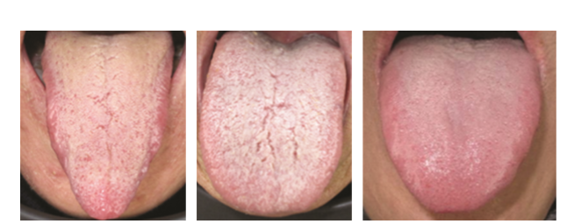

A single feature may not be very discriminative, our premise is that the aggregation of these features will be discriminative. We leave it to the learning algorithm to determine the weight/contribution of each feature in the ﬁnal classiﬁcation. Most color spaces are represented in tuples of number, normally three or four color components. Color components determine the position of the color in the color space used. There are many color spaces deﬁned for diﬀerent purposes. We designed a set of 25 features that span the entire colorspace model. They can be grouped under eight categories: RGB,HSV,YIQ,Y’CbCr,XYZ,L∗a∗b∗,CIELuv,andCMYK.

**RGB**: It’s probably the most popular color space. It stands for Red, Green, and Blue. In this color space, each color is represented as a weighted combination of red, green, and blue. So every pixel value is represented as a tuple of three numbers corresponding to red, green, and blue. Each value ranges between 0 and 255.

ri = Ri/255

gi = Gi/255

bi = Bi/255

Thus, fi1 = ri; fi2 = gi; fi3 = bi.

**YUV :** Y refers to the luminance or intensity, and U and V channels represent color information and also stands for two Chrominance components. This works well in many applications because the human visual system perceives intensity information very differently from color information. The YUV color model represents the human perception of color more closely than the standard RGB model used in computer vision.

U=B-Y V=R-Y

Where B stands for Blue color, R stands for Red color, Y stands for Luminance

$\displaystyle \begin{pmatrix}
Y \\ I \\ Q
\end{pmatrix}=
\begin{pmatrix}
0.30 &...
...& -0.52 & 0.31 \\
\end{pmatrix}\cdot
\begin{pmatrix}
R \\ G \\ B
\end{pmatrix}$

**HSV**: H stands for Hue, S stands for Saturation, V stands for Value. HSV color space is often used by the people who are selecting colors from a color wheel or palette, because it corresponds better to how people experience color than the RGB color space.

V= max=max(R,G,B) min= min(R,G,B)

S=(max-min)/max (or S=0, if V=0)

H= 60\*{ 0+(G-B)/(max-min), if max=R}

{2+(B-R)/(max-min), if max=G}

{4+(R-G)/(max-min), if max=B}

H=H+360, if H<0

Where H is Hue, S is Saturation, V is Value, max and min are maximum and minimum values for corresponding color model.

**YCbCr**: Y stands for luma component and Cb and Cr are the blue difference and red difference croma. It is not an absolute color space. It is a way of encoding RGB information. The actual color displayed depends on the actual RGB primaries used to display the image. It is represented in terms of one luminance component Y and two chrominance components (Cb and Cr), where Cb is the chrominance blue component and Cr is the chrominance red component.

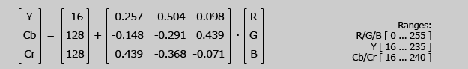

**XYZ :** CIE XYZ, also referred as X, Y, and Z tristimulus functions, and as CIE color space where tristimulus means the 3 reference color stimuli, in a given trichro- matic system, required to match the color. These models are created manually with the help of human judgment ability of visualization and appearances matching, and the chosen colorimetry is based on this matching procedure.

x= X/X+Y+Z

y=Y/X+Y+Z

z=Z/X+Y+Z

$\displaystyle \begin{pmatrix}
X \\ Y \\ Z
\end{pmatrix}=
\begin{pmatrix}
Xr & X...
...Zr & Z_g & Z_b \\
\end{pmatrix}\cdot
\begin{pmatrix}
R \\ G \\ B
\end{pmatrix}$

**CIE L\*a\*b :** They consist of 3 components namely L(lightness),a-color component ranging from green to magenta and b- color component ranging from blue to yellow.The Lab colour space is quite different from the RGB colour space. In RGB colour space the colour information is separated into three channels but the same three channels also encode brightness information. On the other hand, in Lab colour space, the L channel is independent of colour information and encodes brightness only. The other two channels encode colour.

|  |
| --- |
| L= L\*255/100; |
| a= a+128; |
| b= b+128; |

|  |
| --- |
| **CIELUV**: CIELUV was the commonly adopted colour space by the International Commission of Illumination. It is an additive colour model. CIELUV and CIELAB were adopted simultaneously by the CIE when no clear consensus could be formed behind only one or the other of these two colour spaces. The relation between L, u, v is non-linear.    The transformation of the colour space is given by |

**ARCHITECTURE:**

The complete work flow of the proposed method of tongue body and coating segmentation is given in fig which includes initial tongue region segmentation using semi-automated approach using RGB along with edge information; tongue body and coating segmentation using k-means clustering algorithm on CIELAB colour space.

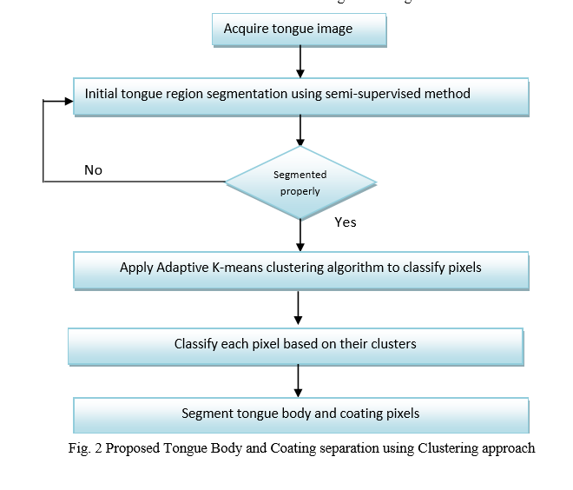

**Segmentation results:**

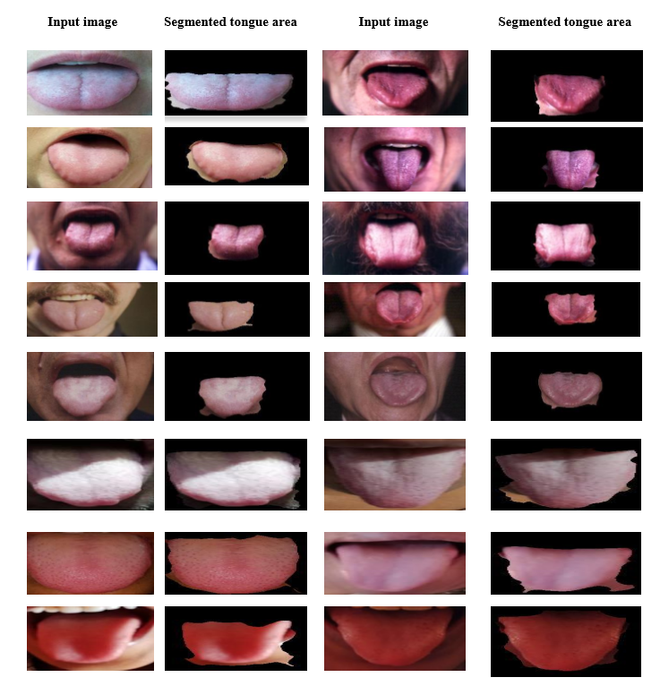

**Clustering:**

After the initial segmentation of the tongue image the clustering of the images are to be carried out and are tested with various clustering algorithms.

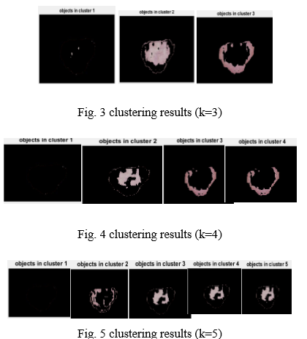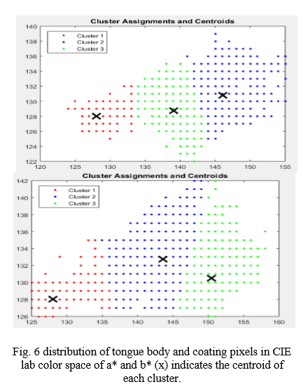  
The above are the results obtained for the clustering of the tongue image with parts as: tongue coating, tongue sideways and the image background.

The area of interest here is the tongue coating (upper part of the tongue ) which is used for analysis of tongue with the initial classification into 3 parts namely vata , pitta and kapha.